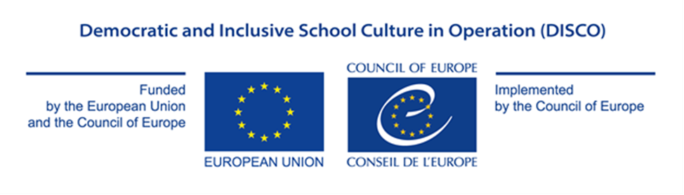

Appendix IV

APPLICATION FORM

GRANT AWARD PROCEDURE

Democratic and Inclusive School Culture in Operation (DISCO)

EU/CoE Joint Programme for international cooperation projects

REF 2017 EDC/HRE DISCO

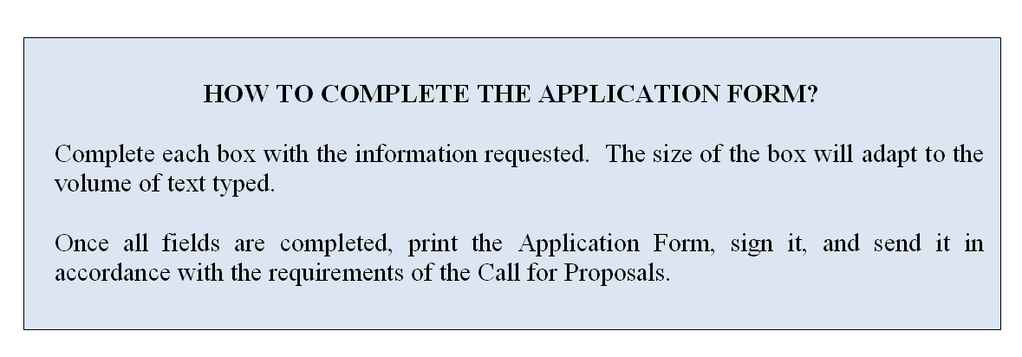

- APPLICANT
Status in the proposed project (indicate “implementing partner” or
“implementing partner in charge”)►
Official name ►
Legal form ►
Full address ►
Website (if any) ►
Name of the person(s) entitled to enter into legally binding commitments on behalf of the implementing partner (indicate name and position) ►
- CONTACT DETAILS
Contact person ►
Position of the contact person ►
E-mail address ►
Phone number ►
- BANK DETAILS
Name of the bank ►
Name of the branch►
Address of the bank ►
Account holder name ►
Full account number or IBAN number (including bank codes) ►
SWIFT (or BIC) Code ►

4. RECENT ACTIVITIES
Describe below the main projects completed or being carried out in the field concerned during the last 2 (two) years ▼
Indicate below grants obtained from States or international institutions during the last 2 (two) years (if any) ▼

5. APPLICANT’S FINANCIAL CAPACITY
Indicate below any information reflecting the applicant’s financial capacity, such as turnover or equivalent (annual budget) for the last 2 (two) years, net earnings (if any), total balance sheet or budget, or medium and long-term debt (if any) ▼

6.APPLICANT’S PROFESSIONAL CAPACITY
Indicate below the number of permanent and temporary staff ▼

7. APPLICANT’S OPERATIONAL CAPACITY
Indicate below how the applicant intends to implement the proposed activities (where applicable, indicate the involvement of third parties including providers) ▼

8. CO-FUNDING
Please explain your available resources and needed resources to implement the project. Indicate below how the implementing partner intends to contribute to the project (either by way of its own resources or by contribution from third parties). Co-financing may take the form of financial or human resources, in-kind contribution or income generated by the action.

Remark concerning the budget table (appendix II): The budget will not cover operating costs of national administration personnel assigned to the project, but only direct, eligible costs such as travel, hotel, special costs associated to meetings (venue, interpretation, stationery, secretariat, etc.). Exception may be made for contracting national experts (working language English) to help planning and coordinating project activities and inasmuch as non-governmental entities (national or international) are called in to participate in the project, for expertise and research, with standard fees being accepted as part of the budget. Please submit one budget table per partner country. ▼

9. DECLARATION
By signing this form I, the undersigned, authorized to represent the applicant, hereby certify that the information contained in this application is correct and that the applicant has not received or applied for any other Council of Europe funding to carry out the action which is the subject of this grant application.

I, the undersigned , agree with the proposed project and my role in its implementation as provided in the Project Proposal Form and authorize the implementing partner in charge to sign the Project Proposal Form in my name.

I certify on my honour that the organisation is not in one of the situations which would exclude it from taking part in a Council of Europe grant award procedure, and accordingly declare that the organisation:

a. has not been sentenced by final judgment on one or more of the following charges: participation in a criminal organisation, corruption, fraud, money laundering;

b. is not in a situation of bankruptcy, liquidation, termination of activity, insolvency or arrangement with creditors or any like situation arising from a procedure of the same kind, or is not subject to a procedure of the same kind;

c. has not received a judgment with res judicata force, finding an offence that affects its professional integrity or constitutes a serious professional misconduct;

d. does comply with its obligations as regards payment of social security contributions, taxes and dues, according to the statutory provisions of the country where it is established.

10. SIGNATURE
Name / First name of the Signatory ►
Title of position in the organisation of the implementing partner submitting the proposal ►
Place of signature ►
Date of signature ►
Signature and official stamp of the implementing partner submitting the proposal ►

