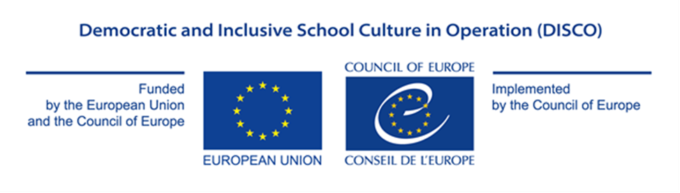

Appendix I

APPLICATION FORM

GRANT AWARD PROCEDURE

Democratic and Inclusive School Culture in Operation (DISCO)

EU/CoE Joint Programme for international cooperation projects

REF 2017 EDC/HRE DISCO

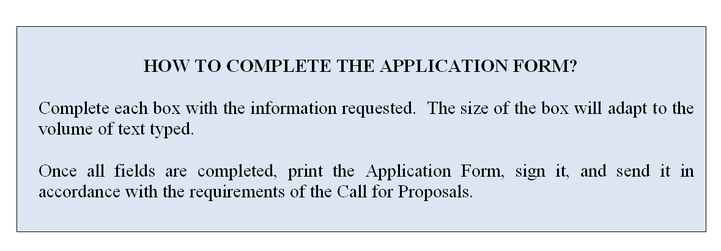

PROPOSED ACTION

- Project overview: Please provide a description of the project:
Title ►
Overall aim ►
Outcomes (Specific Objectives) ►
Applicant country ►
Participating organisations/institutions and their roles (ex. Implementing institution, pilot school) ►
Outputs (Expected results) ►
The Council of Europe Tool to be used (chose only one of the options from the drop down menu):► | Output of the previous programme cycles under the name of “Human Rights and Democracy in Action” to be disseminated and/or developed further.  Choose an item.

- Detailed description of Activities (Maximum 1 page)

Please explain how project activities will be implemented. ▼

- Appropriateness and relevance of the action in accordance with the Charter

Please explain how the project will contribute to the aims and objectives agreed by the Council of Europe member states in the Charter on citizenship and human rights education (in the primary, secondary (lower and higher) and initial vocational education and training levels), in accordance with the present Call for Proposals. Please note in particular that the grants will fund projects designed to contribute to the sustainable development and promotion of education for democratic citizenship and human rights education. ▼

This specific call for proposals will focus on the dissemination and/or further development of the outcomes of the previous cycles of the programme under the name “Human Rights and Democracy in Action”.

- Potential impact on educational policy and practice in the participation countries

Please describe how the project will impact the educational policies and practices in the participating country, including possible ways of evaluating such impact (1-2 years after the project) ▼

- Potential for awareness raising at national and/or international level
Please describe how the project will contribute to increased visibility and awareness of the role of citizenship and human rights education for the future of democratic societies and specify what visibility material is expected to be produced (ex. video and/or audio products, coverage on relevant websites, the use of social media, coverage in specialised magazines, other publications) ▼

- Participation of NGOs, youth organisations/associations, parents associations in the project design and implementation
Please describe how non-governmental organisations (national or international), youth organisations/associations and parents associations will contribute to the project design and implementation. In particular, you might wish to provide an indicative list of organisations, number of organisations, methodology for cooperation, your previous experience with respect to cooperation and potential for sustainability for such cooperation. ▼

- Human Rights Approach
Please indicate:
- How gender equality is relevant to your project and explain how men and women will be included in the project, and whether the project will affect men and women differently.
- What vulnerable groups can be identified in relation to the project? What factors potentially contribute to inequalities for these groups (power, status, resources)? and explain in what ways the project will include these groups and have an impact on them.▼

- Participation of the States party to the European Cultural Convention, which had not previously taken part in this Programme
Please indicate whether one or more of the following countries are among the partners for the present project proposal:
1. Azerbaijan 2. Bosnia and Herzegovina 3. Denmark 4. Holy See 5. Iceland 6. Kazakhstan 7. Liechtenstein 8. Luxembourg 9. Malta 10. Monaco 11. Netherlands 12. Norway 13. Portugal 14. Republic of Moldova 15. San Marino 16. Slovenia 17. Switzerland 18. “the former Yugoslav Republic of Macedonia” 19. Turkey 20. Ukraine ▼

 | - Action plan
 | Briefly present your plan for the implementation of activities until 31 March 2019 ▼
Activity |  | 2018 |  |  |  | 2019
Month |  | 9 | 10 | 11 | 12 | 1 | 2 | 3 | 4

- APPLICANT
Official name ►
Legal form ► | Are you a public entity according to national law/other regulation applicable to you? Yes No  Are you a non-for-profit organisation according to national law/other regulation applicable to you? Yes No
Full address ►
Website (if any) ►
Name of the person(s) entitled to enter into legally binding commitments on behalf of the implementing partner (indicate name and position) ►
- CONTACT DETAILS
Contact person ►
Position of the contact person ►
E-mail address ►
Phone number ►
- BANK DETAILS
Name of the bank ►
Name of the branch►
Address of the bank ►
Account holder name ►
Full account number or IBAN number (including bank codes) ►
SWIFT (or BIC) Code ►

4. RECENT ACTIVITIES
Describe below the main projects completed or being carried out in the field concerned during the last 2 (two) years ▼
Indicate below grants obtained from States or international institutions during the last 2 (two) years (if any) ▼

5. APPLICANT’S FINANCIAL CAPACITY
Indicate below any information reflecting the applicant’s financial capacity, such as turnover or equivalent (annual budget) for the last 2 (two) years, net earnings (if any), total balance sheet or budget, or medium and long-term debt (if any) and please attach relevant documentation to this application ▼

6.APPLICANT’S PROFESSIONAL CAPACITY
Indicate below the number of permanent and temporary staff ▼

7. APPLICANT’S OPERATIONAL CAPACITY
Indicate below how the applicant intends to implement the proposed activities (where applicable, indicate the involvement of third parties including providers) and please attach the Statute of your institution to this application form ▼

8. CO-FUNDING
Please explain your available resources and needed resources to implement the project. Indicate below how the applicant intends to contribute to the project (either by way of its own resources or by contribution from third parties). Co-financing may take the form of financial or human resources, in-kind contribution or income generated by the action.

Remark concerning the budget table (appendix III): The budget will not cover operating costs of national administration personnel assigned to the project, but only direct, eligible costs such as travel, hotel, special costs associated to meetings (venue, interpretation, stationery, secretariat, etc.). Exception may be made for contracting national experts (working language English) to help planning and coordinating project activities and inasmuch as non-governmental entities (national or international) are called in to participate in the project, for expertise and research, with standard fees being accepted as part of the budget. ▼

9. DECLARATION
By signing this form I, the undersigned, authorized to represent the applicant, hereby certify that the information contained in this application is correct and that the applicant has not received or applied for any other Council of Europe funding to carry out the action which is the subject of this grant application.

I, the undersigned , agree with the proposed project and my role in its implementation as provided in the Project Proposal Form and authorize the implementing partner in charge to sign the Project Proposal Form in my name.

I certify on my honour that the organisation is not in one of the situations which would exclude it from taking part in a Council of Europe grant award procedure, and accordingly declare that the organisation:

a. has not been sentenced by final judgment on one or more of the following charges: participation in a criminal organisation, corruption, fraud, money laundering;

b. is not in a situation of bankruptcy, liquidation, termination of activity, insolvency or arrangement with creditors or any like situation arising from a procedure of the same kind, or is not subject to a procedure of the same kind;

c. has not received a judgment with res judicata force, finding an offence that affects its professional integrity or constitutes a serious professional misconduct;

d. does comply with its obligations as regards payment of social security contributions, taxes and dues, according to the statutory provisions of the country where it is established.

e. is not in a situation of conflict of interest.

10. SIGNATURE
Name / First name of the Signatory ►
Title of position in the organisation of the implementing partner submitting the proposal ►
Place of signature ►
Date of signature ►
Signature and official stamp of the implementing partner submitting the proposal ►

