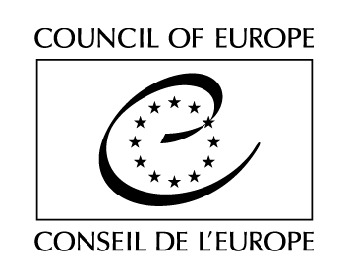
Updated November 2015

EUROPEAN YOUTH FOUNDATION

Guidelines for registration in the EYF Online System

How to access the registration form

From the EYF website http://eyf.coe.int, go to the online system.

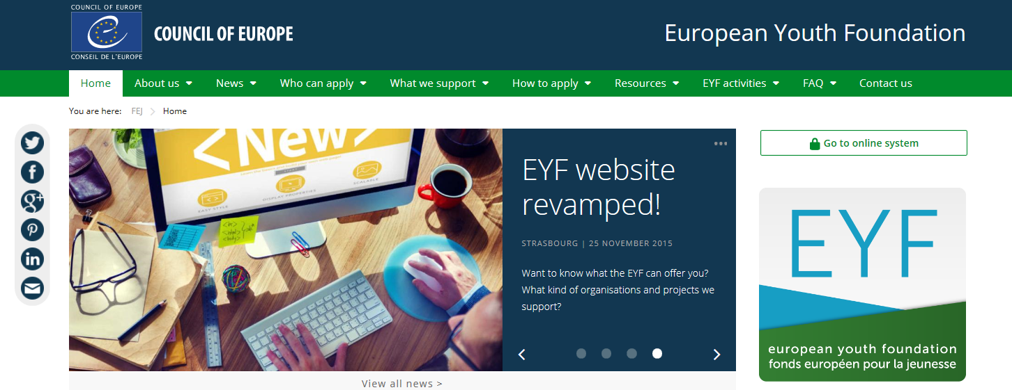

My NGO was registered in the old EYF system (before 2013) > go to page 2.

My NGO is not yet registered with the EYF > go to page 3.

N.B. A Word version of the registration form is available on the Forms and guidelines page of the website.

i. My NGO was registered in the old EYF system (before 2013)

Click on “Login”

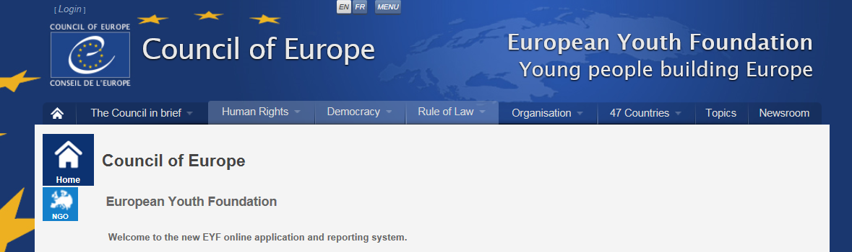

  - To log on to the new online system you will use your organisation’s email address (not your registration number) and the password you used to access the old EYF system.
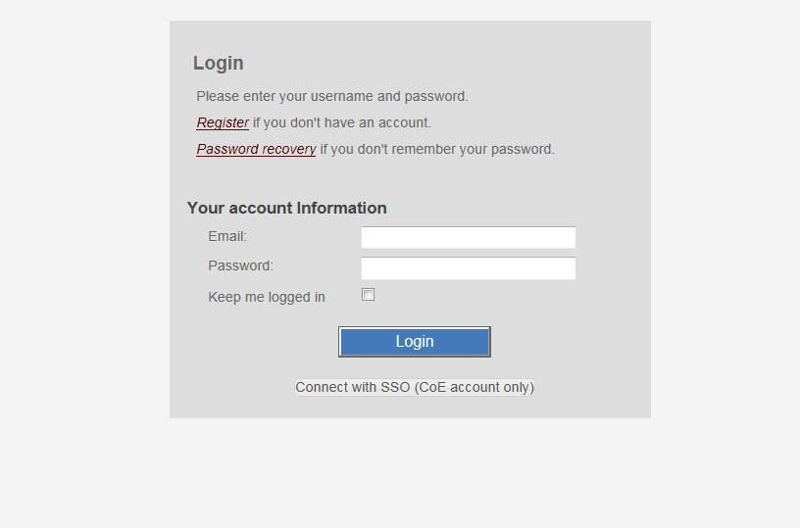
Do not click on “Connect with SSO”

When you click on “Login, you will arrive at the page “General information”, which has partly been filled in with details from your old form. Go to page 4.

ii. My NGO is not yet registered with the EYF

  - Click on the blue button “NGO” and afterwards on “New NGO request”.
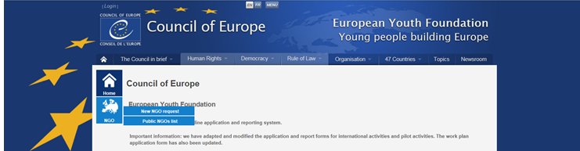

  - Before accessing the registration form you are asked to answer 6 preliminary questions concerning your organisation, which you can answer by ticking “yes” or “no” only. Answer these questions to the best of your knowledge and click on the button “Confirm your answers”.

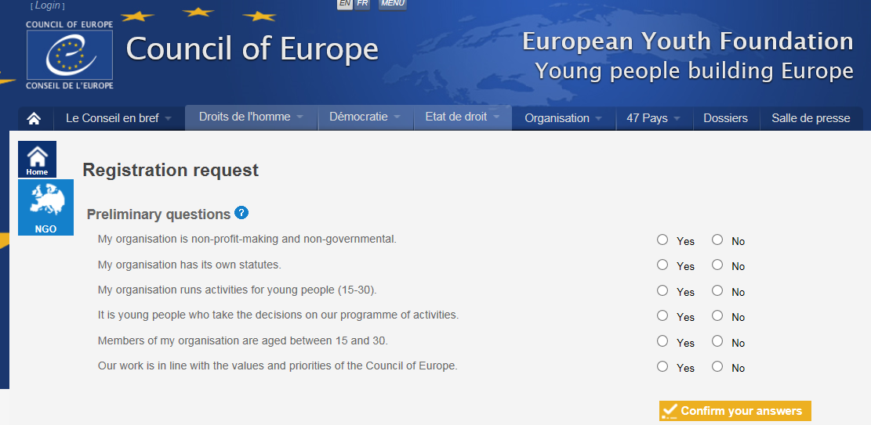

In order to continue you must answer all 6 questions. You can still carry on and fill in the rest of the form even if you answer all questions in the negative, but it is quite certain your registration will not be accepted.

iii. How to fill in the registration form

- After answering the preliminary questions you will directly reach the first tab of the registration form with the title “General Information”.
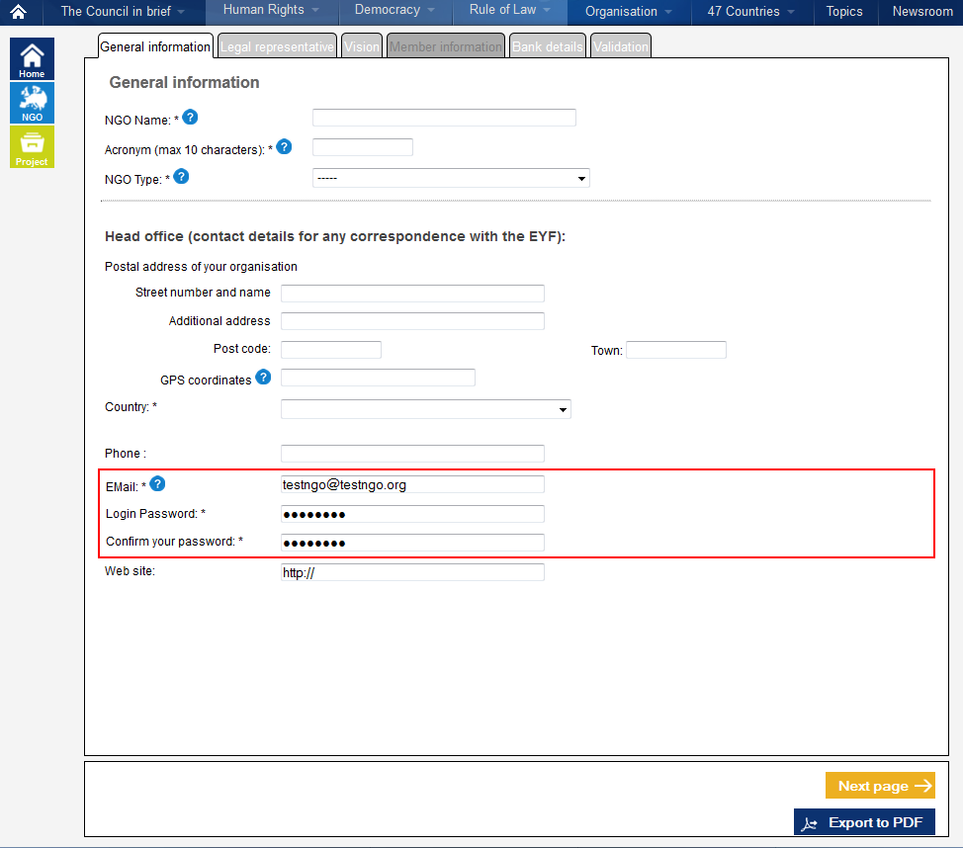
The fields “Email” and “Login Password” are essential at this stage as this email and password (which you can choose) will be your login to the online system in the future. Furthermore you will be contacted throughout the registration process through this email. Therefore we strongly recommend you to use a general email of your organisation (i.e. ngoname@home.org) instead of a personalised one (i.e. myname@home.org).
Each organisation can only use one email for the login.

  - The fields with * are obligatory, meaning these fields must be filled in otherwise the registration form cannot be submitted to the EYF.

  - There are 5 obligatory tabs to be completed in the registration form (General information, Legal representative, Vision, Member information and Validation). The tab “Bank details” will become obligatory if your registration is validated and you receive an EYF grant.
Please take your time to fill in the form.
  - If you do not understand which information is required in certain sections move the cursor on the question mark and a short explanation will appear next to it.
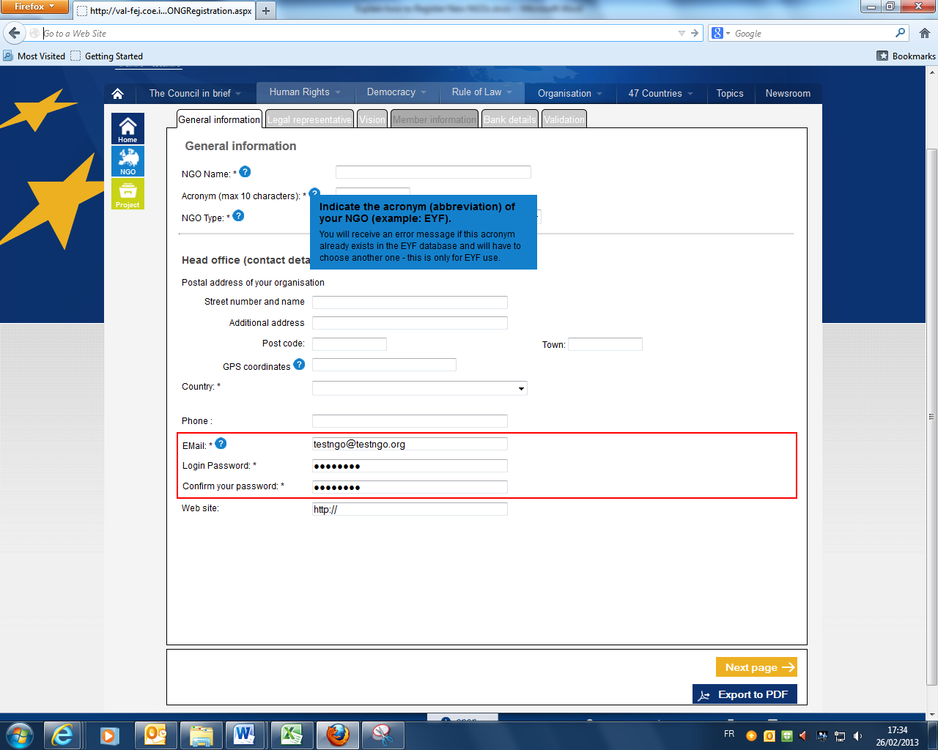

  - Your GPS coordinates are needed to feed the map on the EYF website.

  - After completing the information of each tab you must click on the button “Next page” at the bottom of the page on the right hand side.

  - You will not be able to submit the registration form without attaching a copy of your statutes (in the original language plus a translation and/or summary in English or French) and your most recent annual activity report (if you do not publish an annual report, attach a detailed list of your recent youth activities). Please upload these documents in the tab “Vision”.

- The tab “Member information” is only accessible for:

- International youth organisations
- International networks of youth organisations
- Regional networks of youth organisations

- If your organisation is established at international or regional level you will be asked to provide a description of each member/branch and a contact person (name, function, e-mail). In this case click on the button “Add member” on the right-hand side.
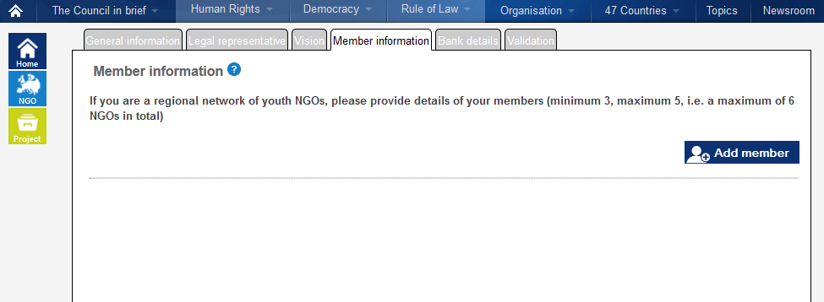
- Fill in a page for each member (the fields with * are obligatory) and click on “Save” at the bottom of the page.

- After completing the registration form, click on “Submit your NGO” at the bottom of the tab “Validation”.
You will receive error messages if any of the obligatory fields have not been filled in.

- If your registration form has been submitted correctly, the following message will appear on the screen:

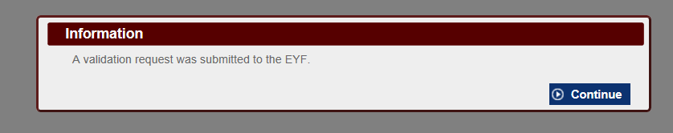

iv. After submitting your registration form to the EYF

- Your registration form has the status “New”.

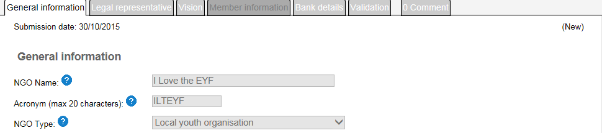

- You cannot modify anything on the form until the EYF Secretariat has validated your registration or given you access to the form again by asking for further information. But if you have any questions you can add a comment if necessary.
- Click on “Add a new Comment” in the tab “Comment”.
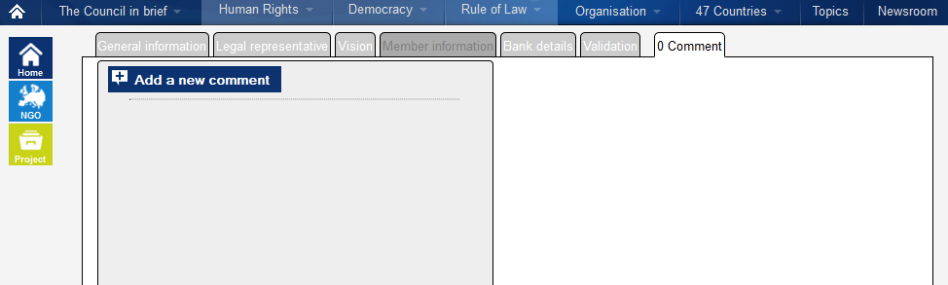

- Write your comment or question in the box which opens and then you click on the button “Add your Comment”.

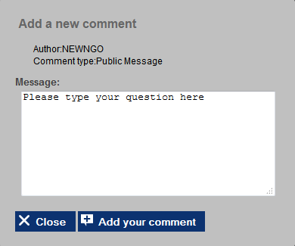

- Your comments will appear in orange on the left hand side in the tab “Comment”.
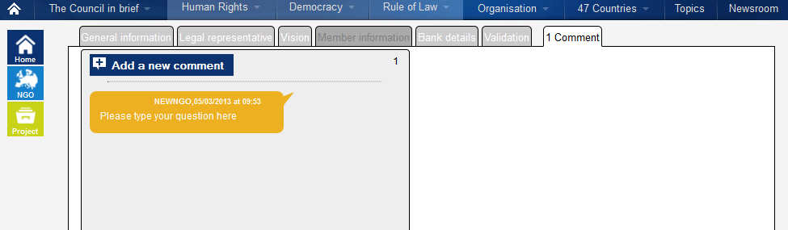

- You will be informed by email when the EYF responds to your comment. If you log on to the online system again and open your form from the NGO menu, you can see the EYF comments in the tab “Comment” on the right hand side.
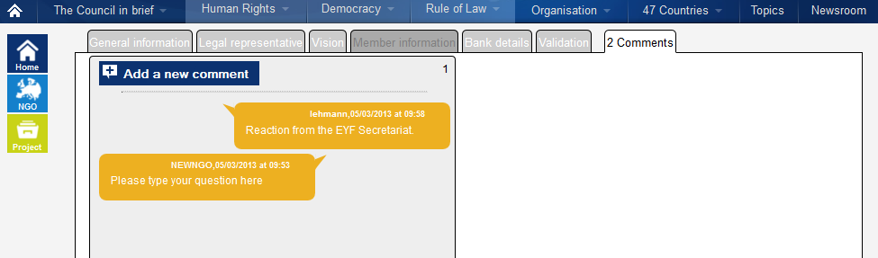
The numbers of comments in this section are counted in the tab “Comment” at the top on the right hand side of the page.
During this period of exchange the status of your organisation does not change – your organisation will remain in status “New”.
Allow 15 days for your registration request to be processed. The more detailed and complete your form is, the quicker it will be dealt with!
- If the EYF needs more information about your organisation you will be informed about this by e-mail and you will be able to access your form.
- In this case you should login to the registration form again (use your e-mail address and the password which you indicated in the registration form). As you can see on the right hand side of the page the status of your organisation changed into “Resubmit”
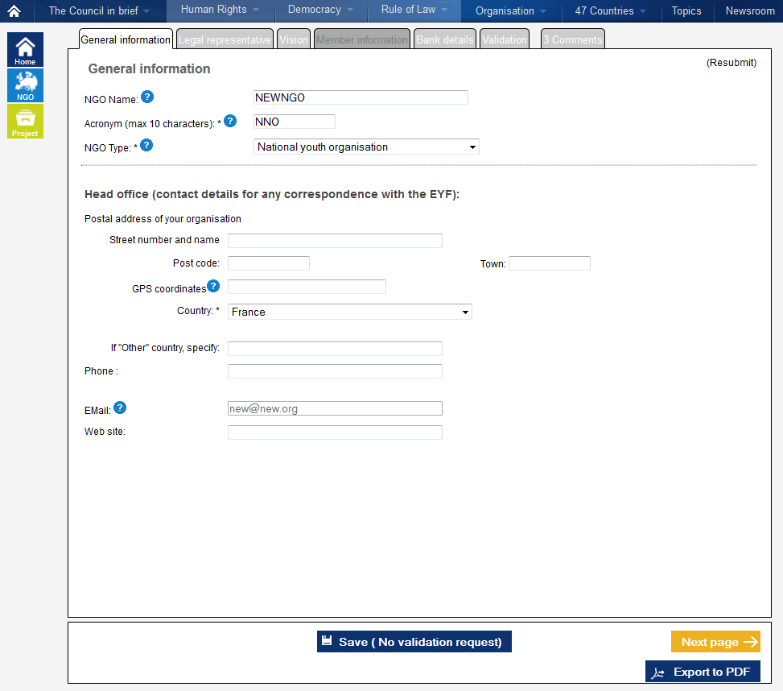
- In the tab “Comment” you can see in the green box which further information is required from the EYF.
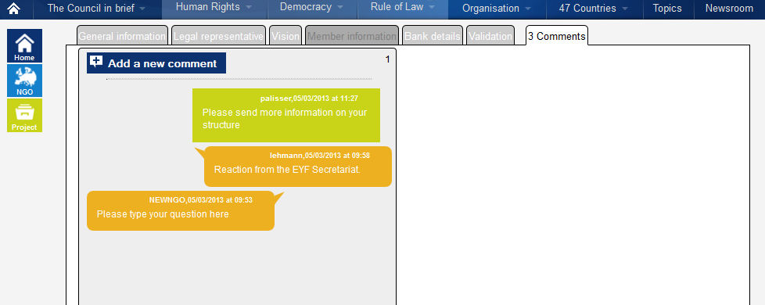
In Status “Resubmit” the form is open again and you are able to modify the requested sections. After finalising the modifications you click on the button “Submit your NGO” at the bottom of the tab “Validation”.
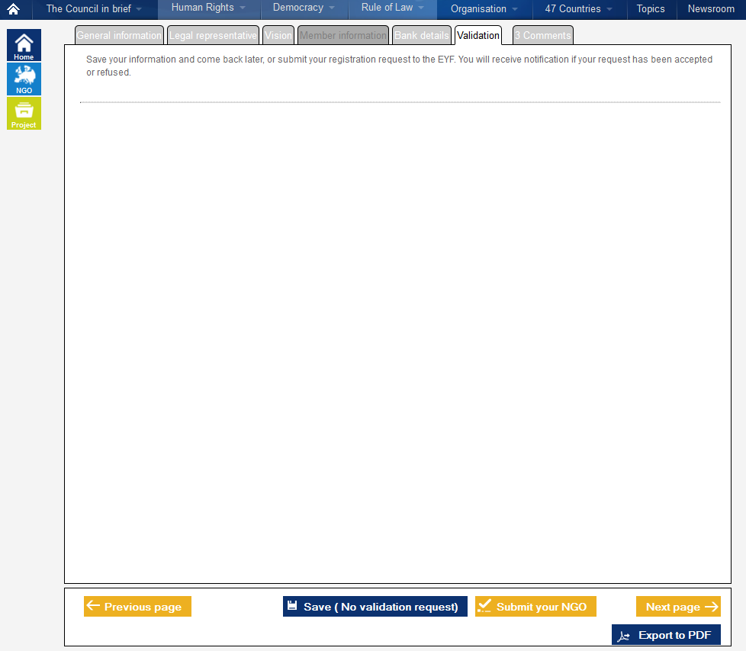

After submitting your NGO again the Status changes back to “New”.
- If your registration is not accepted, you will receive a message explaining why.
- If your registration form is validated by the EYF you will receive a confirmation e-mail and it will have the status “Validated”.
- You will now have access to the application forms in the “Projects” menu.

vi. Modifying the registration form

If you need to update the information in your registration form, log on and go to “Managing your Information” in the “NGO” menu on the left-hand side.
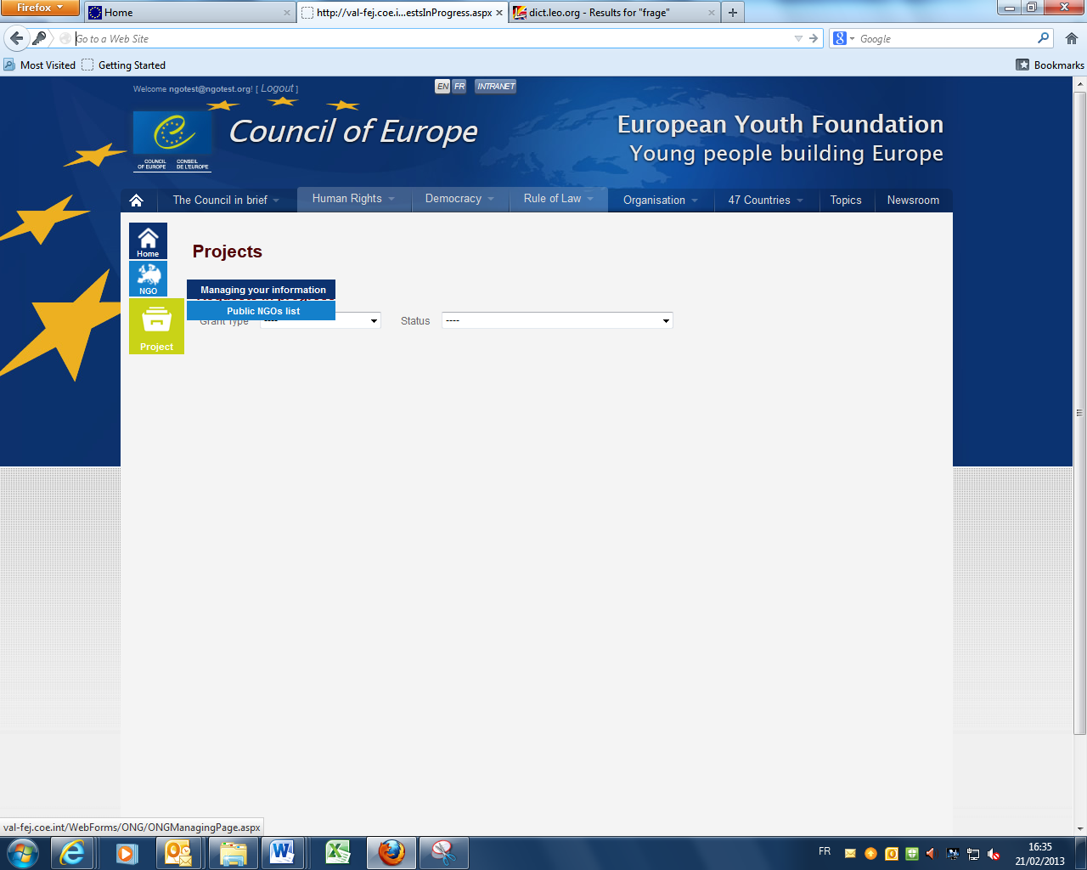
- Click on the button “Change request” at the bottom of the page (this button can be found at the bottom of each tab).
- Once you indicated the changes in the tab you must click on “Save your changes” at the bottom of the page otherwise this information will be lost.
- You can change your password using the “Change password” link.

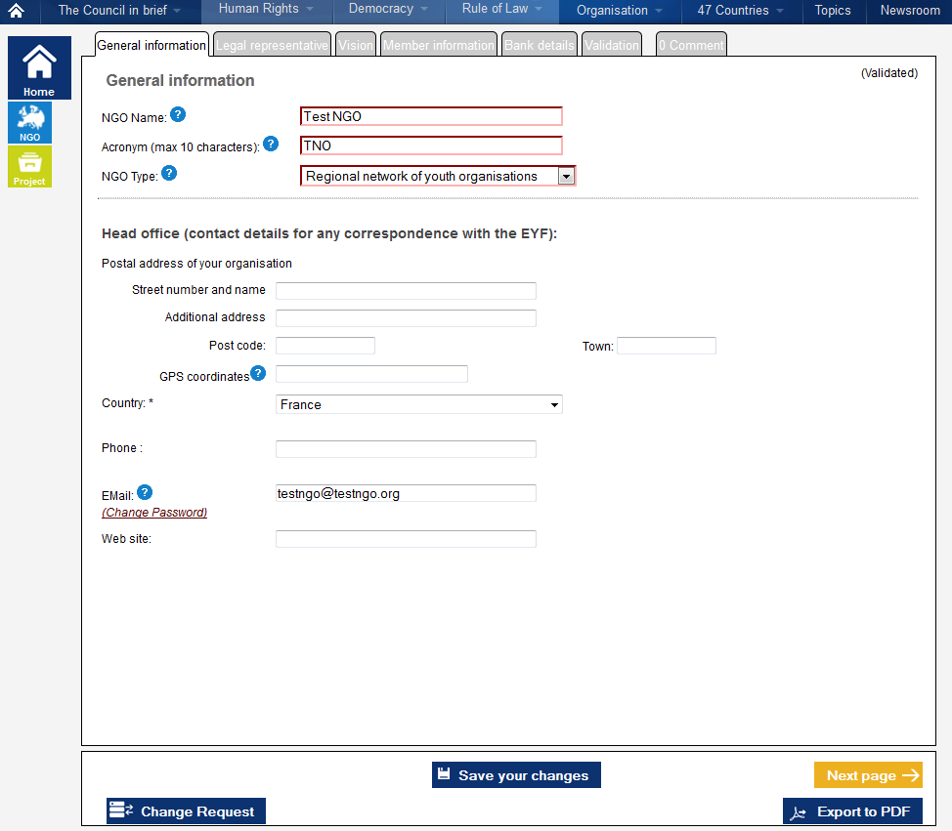

Changes in the red boxes “NGO Name, Acronym, NGO Type” as well as changes in the field “Country” are subject to validation of the EYF.

- You can verify in the last tab “Comment” if these specific change requests have been submitted to the EYF – if you can see a blue box there appearing on the left hand side stating your change request this means your request has been submitted and awaits validation by the EYF.
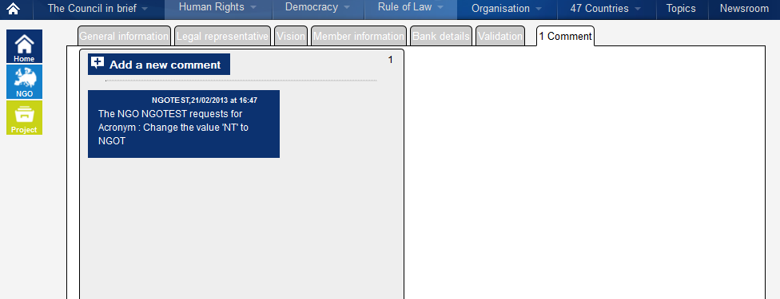

- During this period of validation by the EYF Secretariat the status of your NGO changes into “Awaiting EYF agreement”.

Once your request is validated or rejected by the EYF you will be informed about this by e-mail. Again you will find an explanation in the tab “Comment”. Pending on the validation by the EYF you cannot access any application forms during this time.

