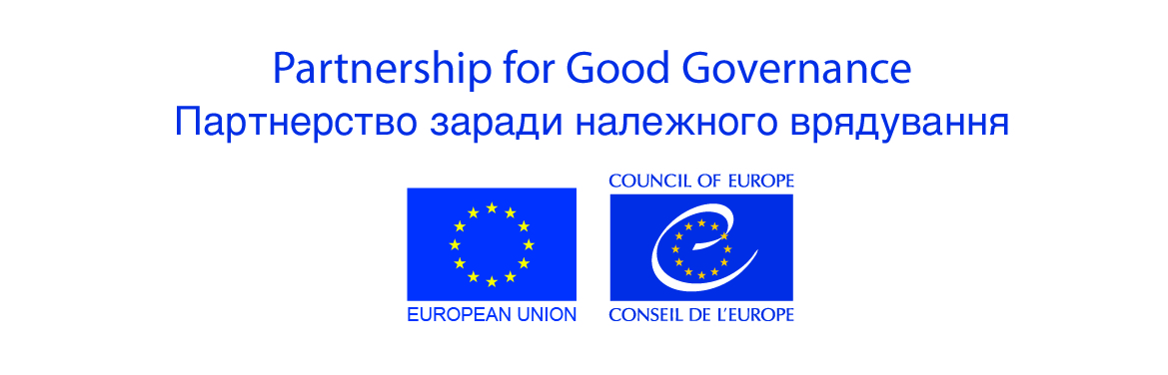
APPENDIX III
TECHNICAL SPECIFICATION for CALL FOR TENDER
Tender # | 4455/2017/80 as of 27 September 2017
Services | Event management services for 3 events:  Event 1: Project CC Meeting, Radisson Blu Hotel, 16 November 2017, 14h00 - 15h30, 25 participants  Event 2: Project Summary Conference, Radisson Blu Hotel, 16 November 2017, 15h45-18h00, 60 participants  Service: Delivery of Catalogue of 12 social and life skills courses to the addresses of Pilot Prisons and 6 Inter-regional administrations of the penitentiary service (13 addresses in total) - deadline by 30 November 2017
Venues | - Radisson Blu Hotel, 22 Yaroslaviv Val  - Radisson Blu Hotel, 22 Yaroslaviv Val  - 13 addresses specified below under Section 12.
Description of services | In the framework of implementation of the PGG Project “Further Support for Penitentiary Reform in Ukraine”, funded by the European Union and implemented by the Council of Europe, the Council entrusts the Service Provider with providing the following event management services to the Project events:  Event 1: Project CC Meeting, Radisson Blu Hotel, 16 November 2017, 14h00 - 15h30, 25 participants  Number of participants: 25. Event duration: 14:00 – 15:30.  The Service Provider shall provide a package of event management service that includes:  - CONFERENCE HALL AND TECHNICAL EQUIPMENT  - Rent and set up of conference hall  Venue: Suite 1-5, Radisson Blu Hotel (22 Yaroslaviv Val St.) in Kyiv. Settings – round table  Please take a note that the conference hall is pre-booked by the Council of Europe. For details, please contact Meeting and Events Sales Coordinator Ms Yuliia Sych at yuliia.sych@radissonblu.com.  - 25 bottles (0,5 l) of still water at the conference hall;  - Rent and set up of technical equipment: i) Sound equipment: 1 radio microphones, 13 goose microphones, speakers, amplifier and mixer; ii) Laptop (with remote presentation controller), screen and projector.  - CONFERENCE SUPPORT  Conference managers should conduct registration of participants, process reimbursement of participants travel costs, should take care of the proper directions to the conference room, provide technical/ organisational supervision at the event, ad hoc requests. The event will require presence of 1 manager on site.  - PRINTING  Print of materials: 50 pages A4, in colour (25 copies), double-sided print;  Name tags for the table  - OTHER  Pick up materials (banners) at the Council of Europe Office (8 Illinska St., Kyiv and deliver them to the venue, compile branded folders with hand-outs and pens; deliver the materials left back to the CoE Office).  Event 2: Project Summary Conference, Radisson Blu Hotel, 16 November 2017,  15h45-18h00, 60 participants  Number of participants: 60. Event duration: 15h30 – 18h00.  The Service Provider shall provide a package of event management service that includes:  - CONFERENCE HALL AND TECHNICAL EQUIPMENT  - Rent and set up of conference hall Suite 1-5, Radisson Blu Hotel (22 Yaroslaviv Val St.) in Kyiv. Settings – theatre.  - 60 bottles (0,5 l) of still water for participants in the hall.  Please take a note that the conference hall is pre-booked by the Council of Europe. For details, please contact hotel manager Lytvynenko, Svitlana <svitlana.lytvynenko@radissonblu.com> or Meeting and Events Sales Coordinator Ms Yuliia Sych at yuliia.sych@radissonblu.com;  - Rent and set up of technical equipment:  - Sound equipment: 8 radio microphones, 5 goose microphones for the presidium, loudspeakers, mixer, amplifier; ii) Laptop (with remote presentation controller), projector and screen;  - Rent of white stage 500 * 200 sm;  - Rent of armchairs - 4;  - Rent of big table for the presidium – 4 persons to be accommodated;  - Construction for the banner (already printed) wall size 500*200;  - Tribune for speakers (with table microphone).  - ACCOMMODATION  Participants should be accommodated at the Ibis Hotel or Hotel of 3 or 4 star (5-star will be also considered if no other hotel venues meeting indicated criteria are available) or located downtown with good transport infrastructure. Single standard rooms with good plumbing, air conditioner, Wi Fi and TV in the room, modern styled and comfortable, room rate to include (not outdated interior) breakfast on 16.10. 17 and dinner on 15.10.17.  - 28 single rooms to be booked and paid by the Service Provider.  - MEALS*  - 2 coffee breaks (Please request the menu from the Hotel manager);  - 1 buffet dinner with wines.  *Please take a note that the menu was pre-selected and is a part of conference package.  - PRINTING  Printing of 150 pages in colour, double-sided, A4 format (plastic comb binding);  Badges for participants;  Printing of the project leaflets (layout is ready for printing, but the logo should be changed);  Printing of 50 pages in black and white, double-sided (agenda, presentations etc);  - Reimbursement of travel expenses  - Reimbursement of travel expenses for participants - Estimated reimbursement amount per participant is 35 EUR, total EUR 980.00.  - CONFERENCE SUPPORT  Conference managers should conduct registration of participants, process reimbursement of participants travel costs, provide technical/organisational supervision at the event, ad hoc requests. The registration desk should be equipped with the laptop and printer (print of materials may be requested at the event), visible signs/directions. The event will require presence of 6 managers on site.  - Other  - Pick up materials (banners) at the Council of Europe Office (8 Illinska St., Kyiv and deliver them to the venue, compile branded folders with hand-outs and pens; deliver the materials left back to the CoE Office).  - To provide the ballpoint pens (automatic, blue ink, white plastic frame) without any logo. Template:  - To produce the block notes (A5 format, clear block, 50 pages, offset printing, 4+0+lamination, offset paper 100 gram, cover: coated, matt 300 gram, metal spring binding). Template:  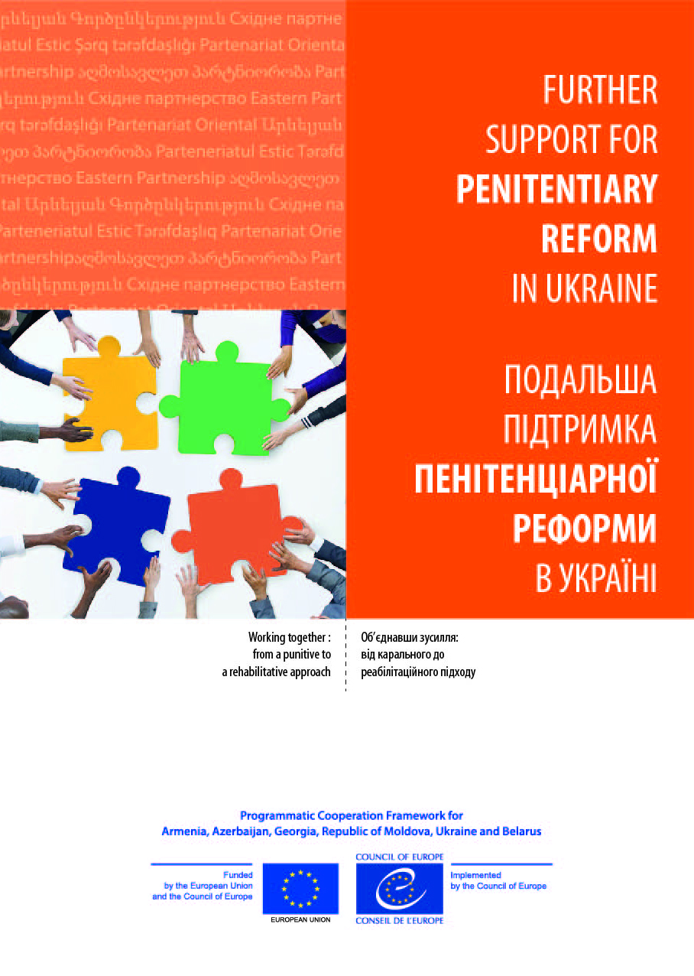  Service: Delivery of Catalogue of 12 social and life skills courses to the addresses  of Pilot Prisons and 6 Inter-regional administrations of the penitentiary service  (13 addresses in total) - deadline by 30 November 2017  112. Delivery services (up to 30 kg per one address) – the publications are located in the storage room of the CoE Office.  List of addresses:  - Delivery to the Pilot prison No 35 in Bila Tserkva (16 Vasylya Symonenka St., Bila Tserkva, Kyivska oblast, Ukraine, 09100)  - Delivery to the Pilot Prison No 44 in Chernihiv (Chernihiv, 38 Promyslova St., 14014)  - Delivery to the Pilot Prison No 81 in Stryzhavka (Stryzhavka town, Vinnytska Oblast, Vinnytskyi district, 30 Aleyi St.)  - Delivery to the Pryluky Juvenile Prison (Pryluky, Chernihivska Oblast, 234 Kyivska St., 17500)  - Delivery to Kremenchuk Juvenile Prison (Kremenchuk, Poltavska Oblast, 10/30 Bohaievskoho St., 39600)  - Delivery to the Pilot Prison No 65 in Bozhkivske (Bozhkivske village, Poltavska Oblast, 12 Parkova St., 38741)  - Delivery to the Bila Tserkva In-Service Traning Centre (Bila Tserkva, 333 Ivana Kozheduba St., 09100)  - Delivery to the Western Inter-regional administration of the penitentiary service (Lviv, 1 Arkhypenka St., 79005 Ukraine)  - Delivery to the Southern Inter-regional administration of the penitentiary service ( Odesa, 9 Liustdorfska Road, 65017 Ukraine)  - Delivery to the Southeastern Inter-regional administration of the penitentiary service (Dnipro, 4 Korolenka St., 49070)  - Delivery to the Northeastern Inter-regional administration of the penitentiary service (Kharkiv, 14 Netichenska St., 61010)  - Delivery to the Central Inter-regional administration of the penitentiary service (Kyiv, 2 Vozdvyzhenska St., 04071)  - Delivery to the Central-western Inter-regional administration of the penitentiary service (Vinnytsia, 2A Ostrovskoho St., 21100)  The full list of the expected services is specified in the APPENDIX II Proposed budget template of the Call for tender for event organisation services 4455/2017/80 as of 26 September 2017
Payment | In return for the fulfilment by the Service Provider of its obligations under the contract, the Council undertakes to pay the Tenderer a fee in EUR or UAH.  - This fee shall be payable within 60 calendar days upon receipt of the deliverables of the contract (listed in Appendix II) and its acceptance by the Council and on presentation of an invoice in and in Euros.  - Advance payment of max 60% is possible.  - Balance payment after conduction of all events within 60 calendar days of submission of the documents.
Service Provider  Eligibility Criteria | To be eligible, applicants must:  - be legally registered under the current legislation;  - have the right to perform the activities, mentioned in the application, in accordance with the applicant’s statutory documents;  - have sufficient financial and operational capacities to operate under a contract with the Council of Europe.  All criteria should be proven documentarily!
Service Provider  Exclusion Criteria | Service Provider should:  - Have not been sentenced by final judgment on one or more of the following charges: participation in a criminal organisation, corruption, fraud, money laundering;  - Are not in a situation of bankruptcy, liquidation, termination of activity, insolvency or arrangement with creditors or any like situation arising from a procedure of the same kind, or is not subject to a procedure of the same kind;  - Have not received a judgment with res judicata force, finding an offence that affects its professional integrity or constitutes a serious professional misconduct;  - Do comply with its obligations as regards payment of social security contributions, taxes and dues, according to the statutory provisions of the country where it is established.  By signing the application form, all bidders declare under their own responsibility that they are not in any of the situations described above. In this regard, the Council of Europe reserves the right to request additional documents from selected candidates.
Service Provider  Award Criteria | Service Provider will be assessed against the following criteria:  - Financial offer – 50 %;  - Quality of services offered, including facilities of the accommodation, delivery services and conference management services – 30 %;  - Working experience in organising similar events and providing high quality event management and logistics support services – 20 %.
Call for tender issued | 27 September 2017
Date of the announcement of the results | 19 October 2017
Documents to be provided by the Service Providers | The application package shall be sent via e-mail to kyiv@coe.int indicating TENDER 4455/2017/80 in a subject line by 16 October 2017, 20h00 Kyiv Time. The deadline is compulsory.  The offer should consist of:  - Tender Application Form all fields fully completed and signed in PDF format;  - Price Proposal, filled in as per all requested service positions in PDF and Excel formats. Submitted PDF formatted documents should be duly signed, stamped, and dated; provided on the Company’s letterhead with name and surname of responsible person. Submitted budget to be in both UAH and EUR, at the CoE rate as of 26/09/2017 1 Eur=31,152 UAH  The estimated budget should be presented in all-inclusive prices which means that companies fees should be included into the proposal.  - Registration certificate;  - Certificate proving the right to render event management services (ДОВІДКА з Єдиного державного реєстру підприємств та організацій України (ЄДРПОУ) про Види діяльності за КВЕД)  If you have any questions, please reach out to Oksana Nechyporuk, +38.044.425.02.62 (ext.124), Oksana.nechyporuk@coe.int

